Test User

1. Keith Njagi - [keithnjagi@gmail.com](mailto:keithnjagi@gmail.com) – k1tg1@n@

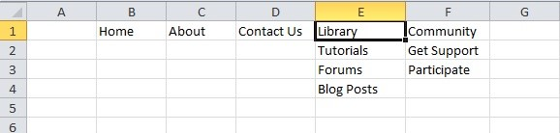

# Home

Goes to home page.

# About

Goes to the about page.

# Contact Us

Redirects you to email.

# Library

Is a dropdown menu.

## Tutorials

Takes you to the tutorials page. Allows you to see tutorials posted by various participants.

## Forums

Takes you to the forums page. Allows you to participate or read through forums.

## Blog Posts

Allows you to see blog posts from people already participating.

# Community

Is a dropdown menu.

## Get Support

Basically this will be a contacts page. Allows you to access client care for participants, legal support, financial support, … etc.

## Participate

Allows logged in individuals to set up their own profiles, make their own blog posts, post their own tutorials…etc

Upon registration, ability to create your own profile.

# FORUMS PAGE

* Sort forums by date, from latest to olders.
* Ability to search for forums.
* Each forum should open independently….. reference app=sololearn forum functionality.